**Process Flow**

|  |  |  |
| --- | --- | --- |
| **Role** | **Responsible** | **Actionable** |
| Initiator | Compliance and implementation | Creation and updation |
| Reviewer | Head ISAD | Accept or reject |
| Approver | CIA/Divisional Head | Final approver |

**FINANCIAL BUDGET SPECIMEN**

**Select Department**

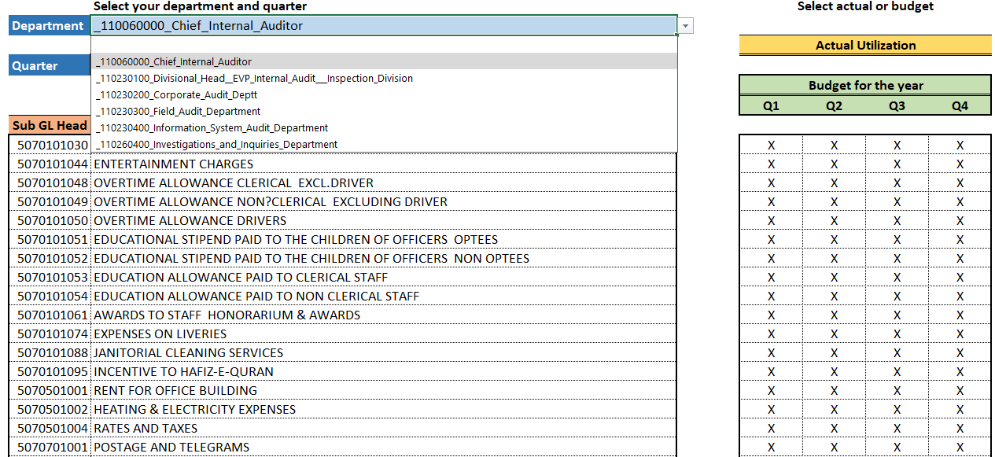

**Select sub office in case of divisional head**

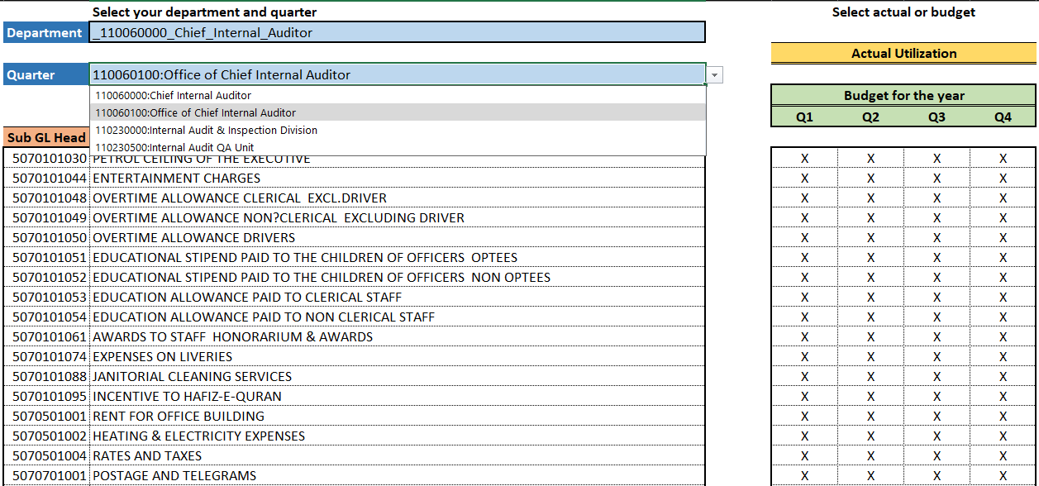

**Select Audit Zone in case of FAD**

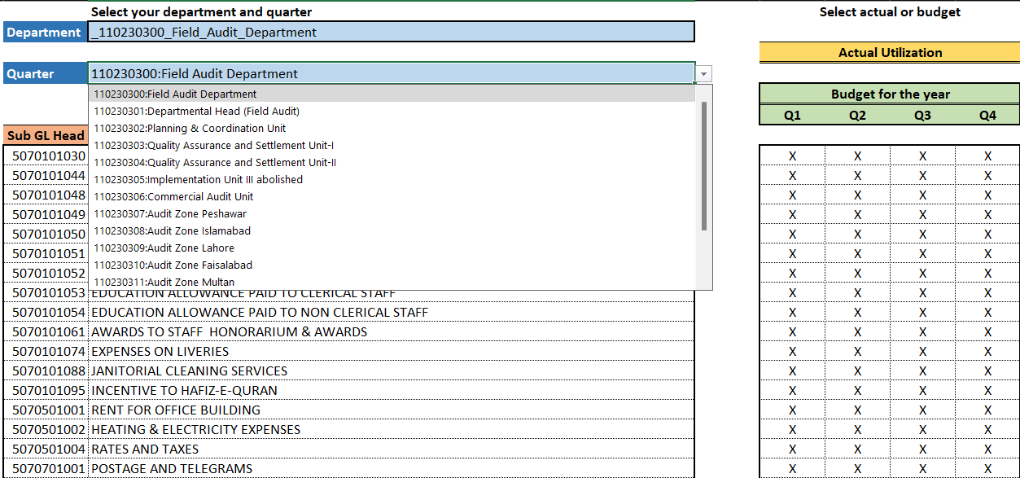

**Select Unit in case of Department**

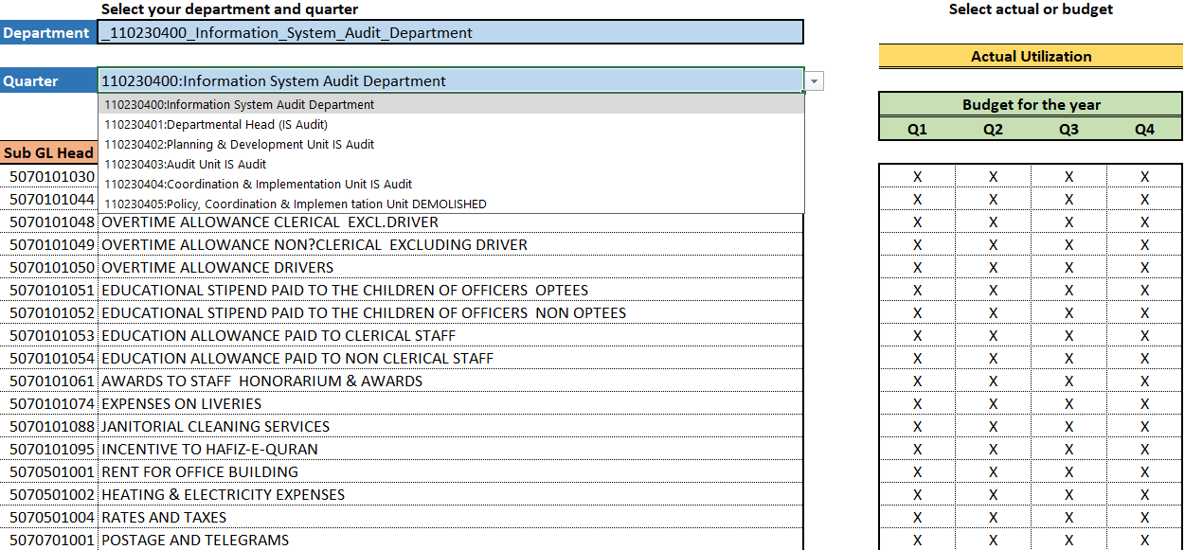

**Select between Budget Utilization (Actual) or Budget**

